Lab Guide

Retail Sales Aggregation by Market Segments

Watsonx.data

IBM Data and AI







Table of Contents

Background 3

Additional resources 4

Documentation 4

Preliminary validation steps: 5

# Background

The next-gen watsonx.data lakehouse is designed to overcome the costs and complexities enterprises face. This will be the world’s first and only open data store with multi-engine support that is built for hybrid deployment across your entire ecosystem.

* WatsonX.data is the only lakehouse with multiple query engines allowing you to optimize costs and performance by pairing the right workload with the right engine.
* Run all workloads from a single pane of glass, eliminating trade-offs with convenience while still improving cost and performance.
* Deploy anywhere with full support for hybrid-cloud and multi cloud environments.
* Shared metadata across multiple engines eliminates the need to re-catalog, accelerating time to value while ensuring governance and eliminating costly implementation efforts.

This lab uses the watsonx.data developer package. The Developer package is meant to be used on single nodes. While it uses the same code base, there are some restrictions, especially on scale. In this lab, we will open some additional ports as well to understand how everything works. We will also use additional utilities to illustrate connectivity and what makes the watsonx.data system “open”.

We organized this lab into a number of sections that cover many of the highlights and key features of watsonx.data.

* Access a watsonx.data
* Starting watsonx.data
* Introduction to watsonx.data components
* Analytical SQL
* Advanced SQL functions
* Time Travel and Federation
* Working with Object Store Buckets

*At the end of each section, you will find the assets (scripts, csv files, etc.) needed to recreate steps in your own environment.

*Please note: This guide will be continuously updated as sample connections to additional technologies become available**.*

## Additional resources

1. Cloud Pak for Data 4.6.6 TechZone Environment <https://techzone.ibm.com/collection/PakInstaller>
2. Installation Guide

<https://ibm.ent.box.com/folder/215224712485>

1. Watsonx.data development lab

<https://techzone.ibm.com/my/reservations/create/64dcc54d3a71eb3685d8da40>

1. IBM Watsonx.data beta version setup

<https://ibm.ent.box.com/file/1241740396395>

## Documentation

The following links provide more information on the components in this lab.

* watsonx.data

<https://www.ibm.com/docs/en/watsonxdata/1.0.x>

* Presto SQL

<https://prestodb.io/docs/current/sql.html>

* Presto Console

<https://prestodb.io/docs/current/admin/web-interface.html>

* MinIO

<https://min.io/docs/minio/linux/administration/minio-console.html>

* Apache Superset

<https://superset.apache.org/docs/creating-charts-dashboards/exploring-data>

* dBeaver

<https://dbeaver.com/docs/wiki/Application-Window-Overview/>

* Db2 SQL

<https://www.ibm.com/docs/en/db2/11.5?topic=queries-select-statement>

* PostgreSQL SQL

<https://www.postgresql.org/docs/current/sql.html>

## 

Pre-Requisites:

1. IBM Cloud Account
2. Python Server
3. Kafka Server
4. Access to IBM DB2 Database
5. Watsonx.data installation and accessing it

# Preliminary validation steps:

1. Installation and configuration of Watsonx.data

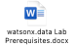

1. DB2 access steps:
2. IBM Cloud access validation by login to -- <https://cloud.ibm.com>

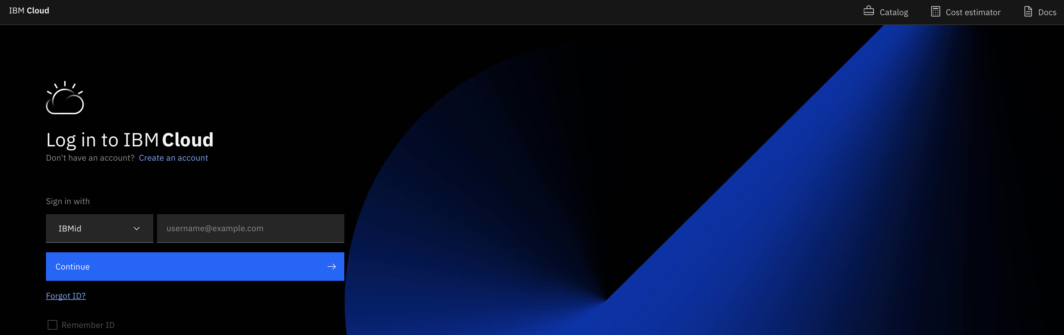

1. Navigate to the resources list from Hemberger menu



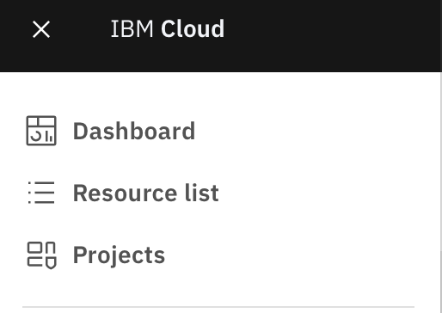

1. From resource list select Databases and check for DB2 is created or not

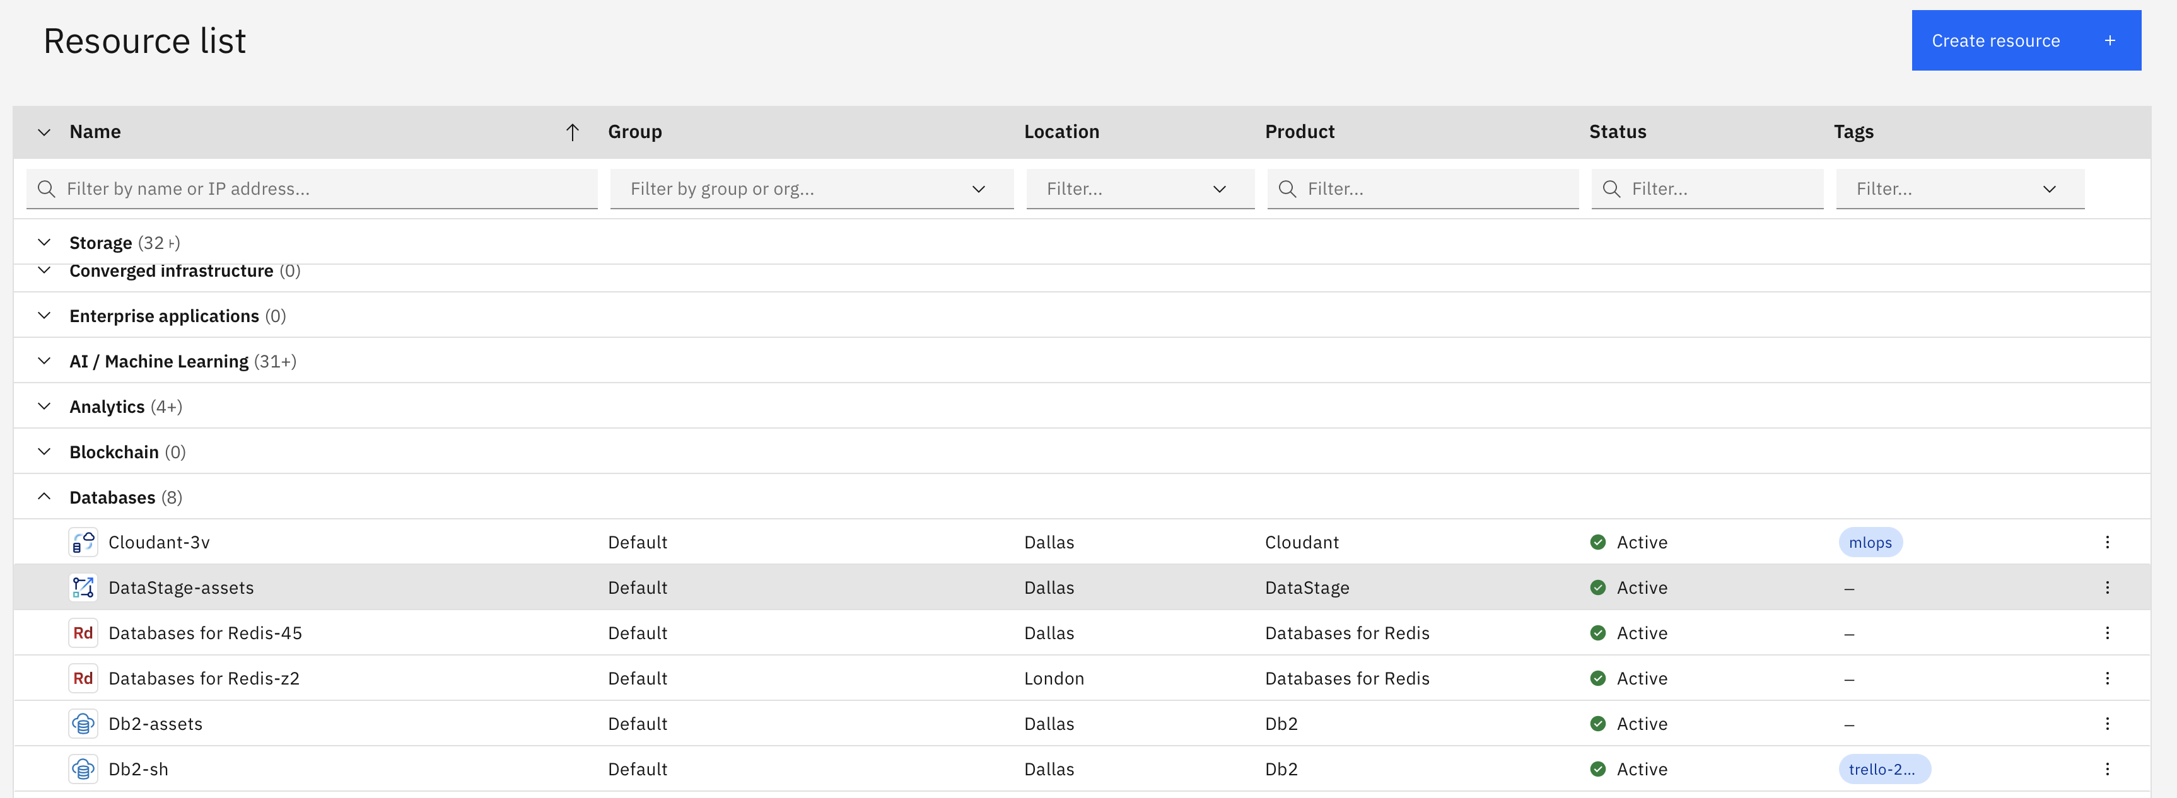

1. Click on DB2 instance

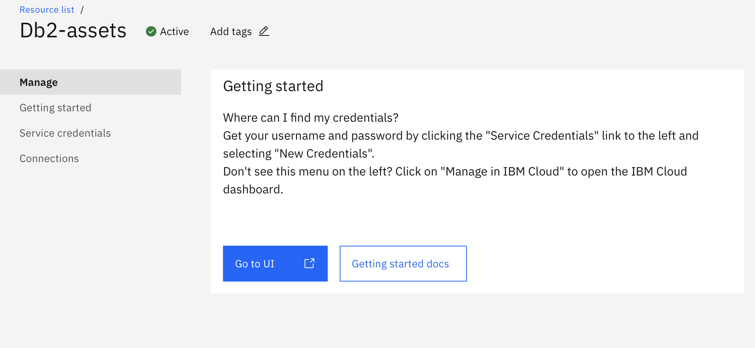

1. Go to service credentials and copy the credential details required to add in watsonx.data environment

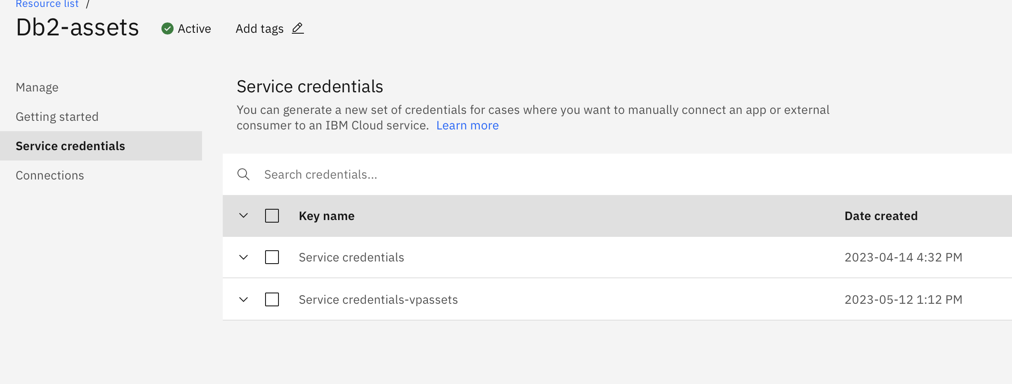

2.) Python Server Installation and configuration:

1. Download the Python latest version from below URL

<https://www.python.org/ftp/python/3.11.4/python-3.11.4-macos11.pkg>

2. install python & Jupiter notebook

<https://jupyter.org/install>

3. start the jupyter notebook using the below command

# **jupyter** notebook --ip=169.60.148.131 --port=8888 --allow-root --notebook-dir=/root/ &

The above command will start the jupyter notebook server and it gives us the url with token to fetch the latest python notebook file like

<http://169.60.148.131:8888/?token=971a1a9a3c31d9f09d771bcb3acab7239898c44ea83cf5af>

This URL is going to open the notebook file which you have created to access watsonx.data environment if you have made the similar settings in the python server

The Files are available as part of the box files

1. Python script
2. Alias script
3. Gen Data script
4. Kafka Server - Downloading and installation steps
   1. Download source location

<https://kafka.apache.org/downloads>

* 1. Unzip the file using

tar xvzf kafka_2.11-0.11.0.0.tgz

* 1. Create softlink of kafka directory

ln -s kafka_2.11-0.11.0.0/ kafka

* 1. Edit /opt/kafka/config/server.properties and change the listeners property

Update or review the below details:

listeners=PLAINTEXT://0.0.0.0:9092

* 1. Reload and start the systemd services

systemctl daemon-reload

systemctl start kafka-zookeeper.service

systemctl start kafka.service

* 1. Finally check the status of Kafka server is running or not

systemctl status kafka.service 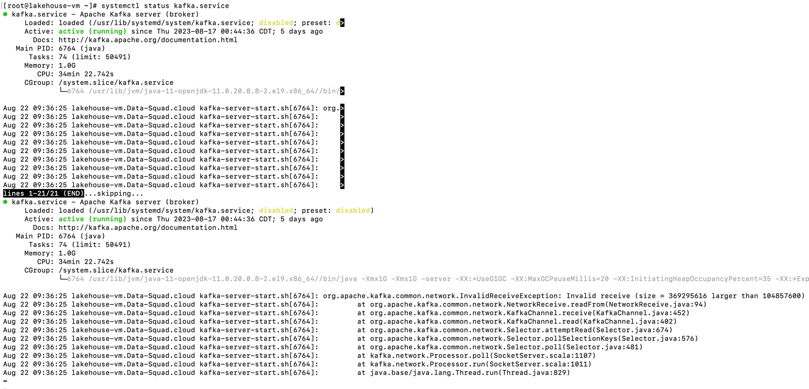

Start with Watsonx.data

Step 1:

Login to Unix/Linux box where we have installed all the applications like python, kafka and watsonx.data

Step 2:

Set or verify the PATH variable for the below values :

export LH_ROOT_DIR=/root/lakehouseinstall

export PATH=$PATH:$LH_ROOT_DIR/ibm-lh-dev/bin

Step 3:

After login to the box navigate to the ibm-lh-dev/bin directory to start the watsonx.data server

Step 4:

Verify if any docker is in running state

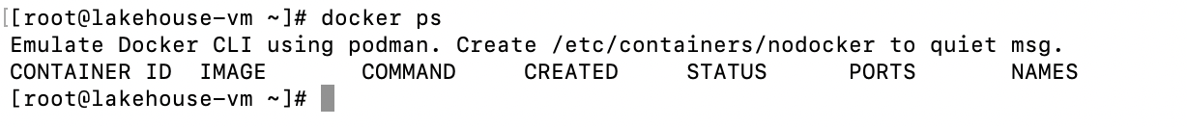

Step 5:

Start the watsonx.data by executing start script from the bin directory

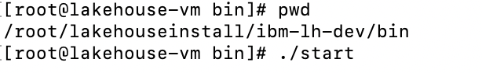

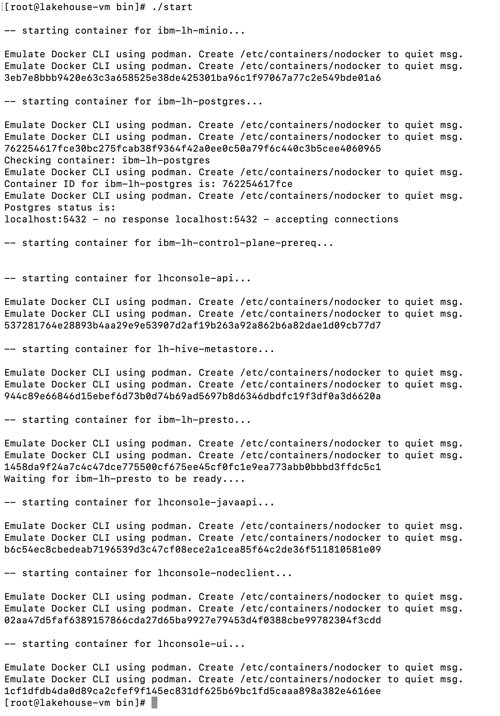

Step 6:

Verify the docker running status using docker ps command

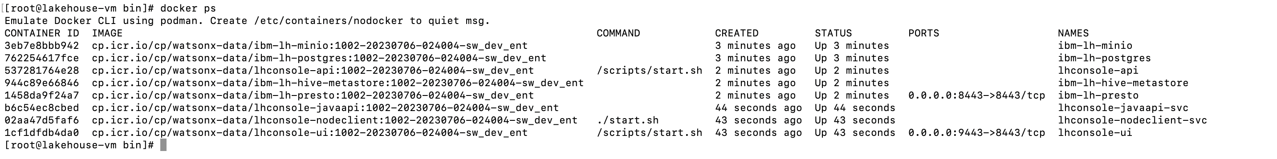

Now, we are good to execute queries on Watsonx.data, before this we are going to check the other services are up and running

Step 7:

Open the URL of watsonx.data

<https://169.60.148.131:9443/#/home>

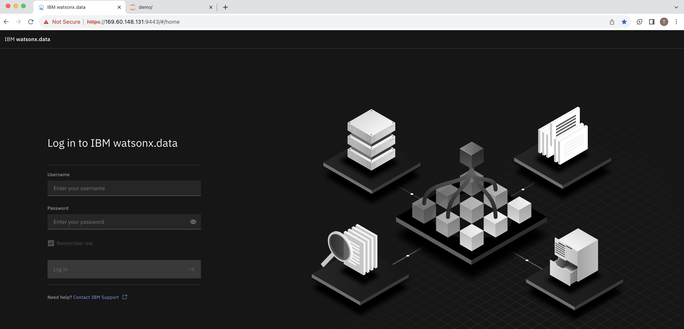

Use Credential to login

User Name : ibmlhadmin

Password: password

Step 8:

Login using the credentials mentioned above ; on successful validation of credential you will land to the below home page

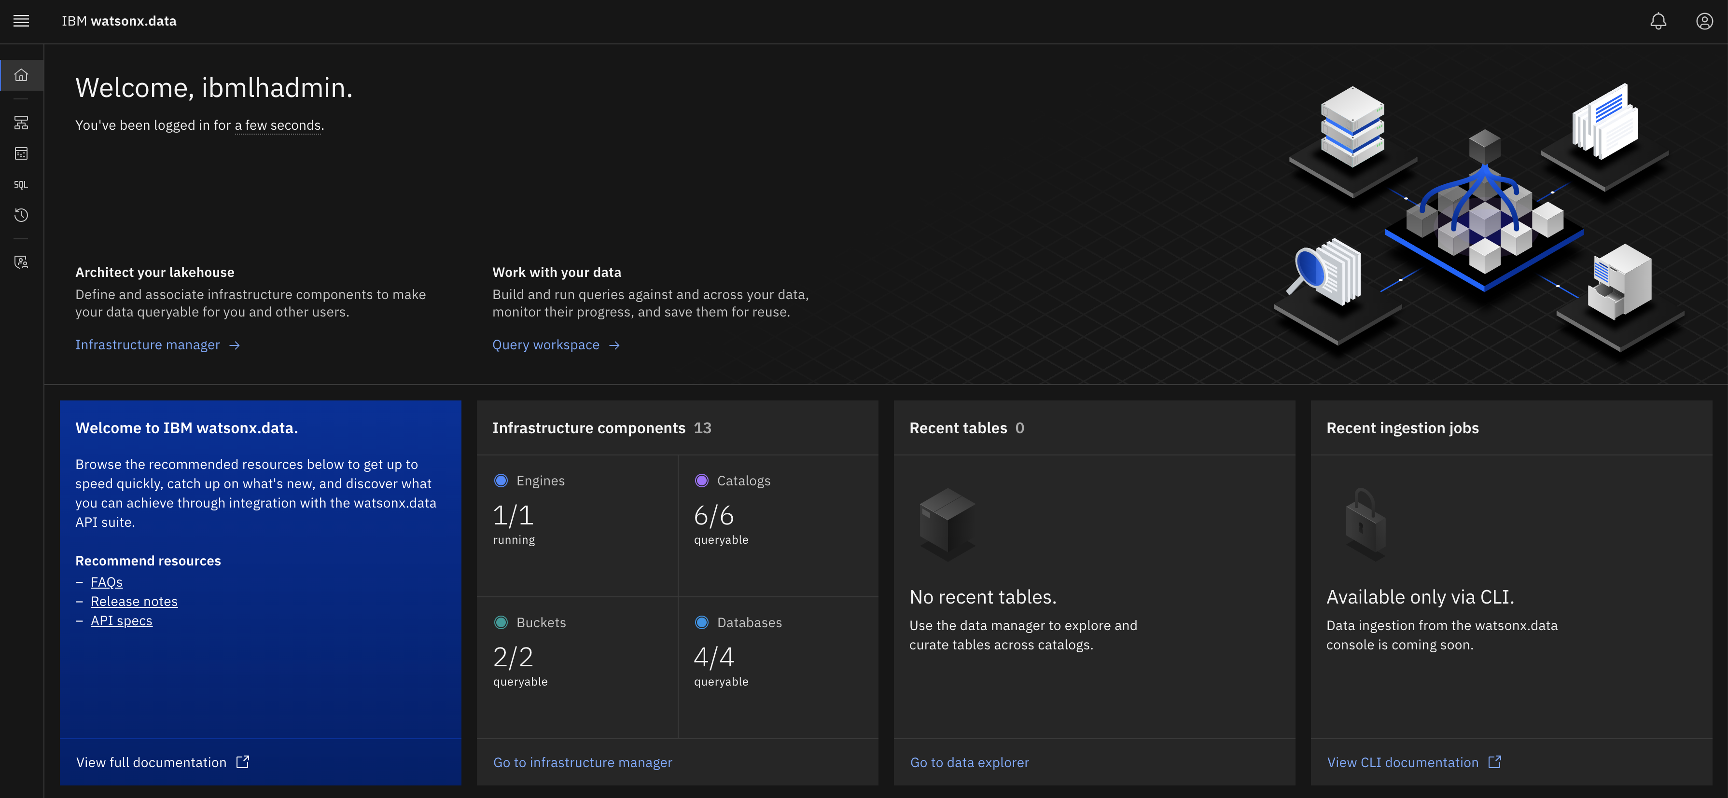

Step 9:

Click on infrastructure manager to see all the added Catalogs with buckets and databases

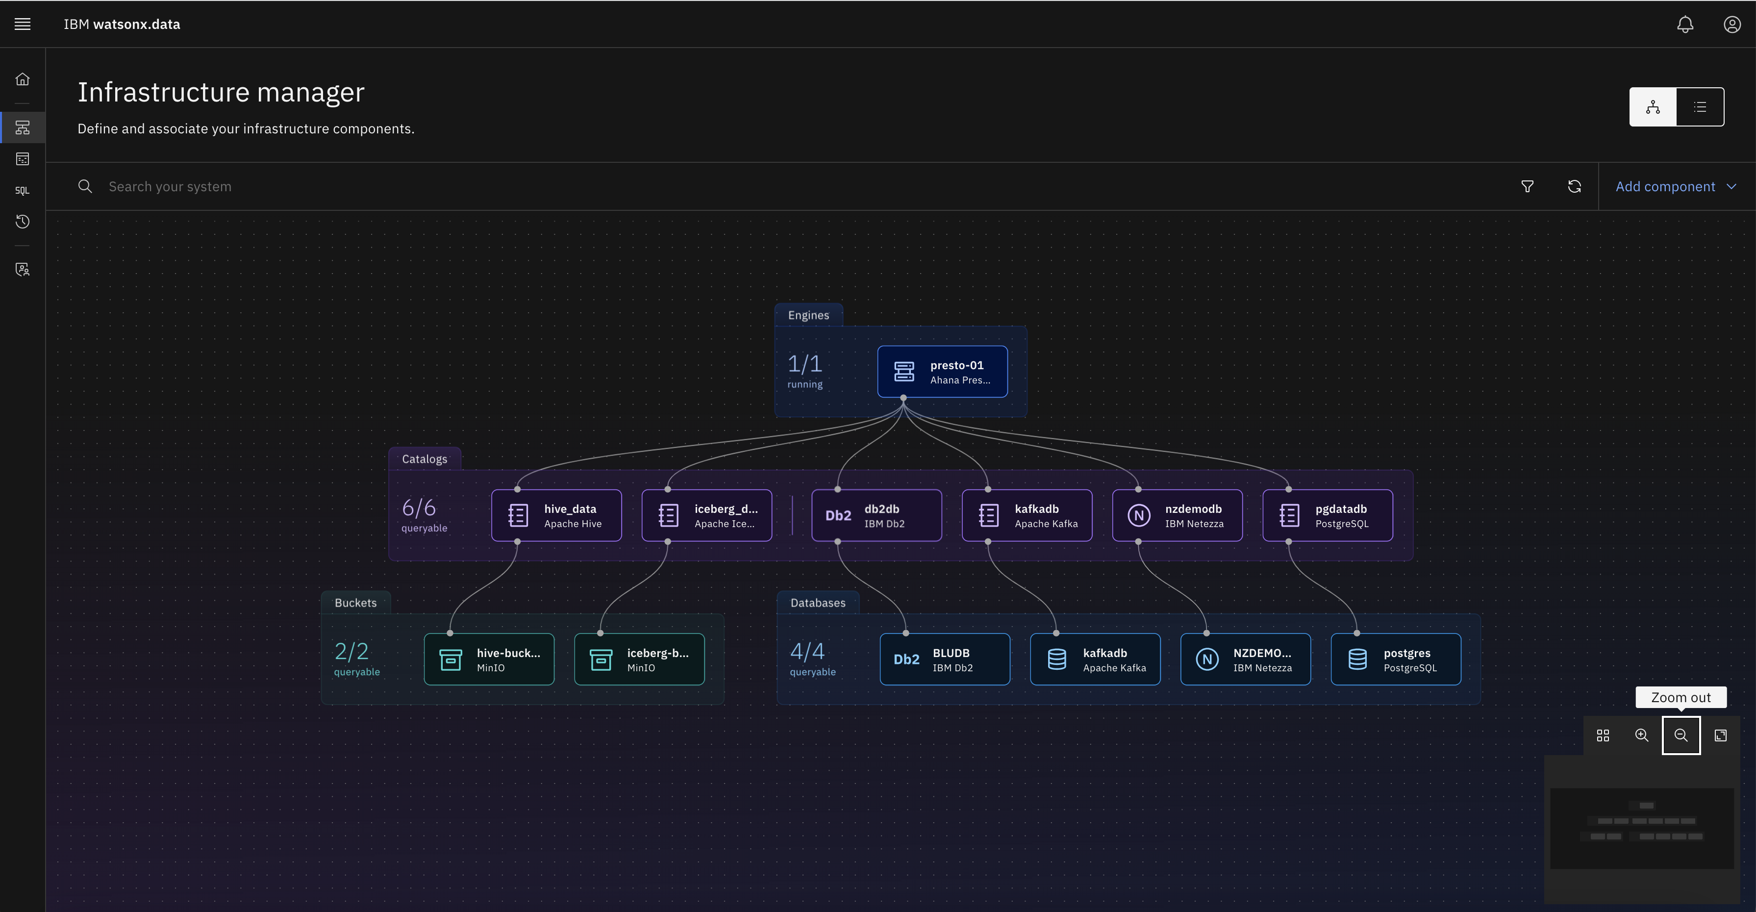

Step 10:

When you click on the Add component then you can add bucket or database connection to watsonx.data to federate the data

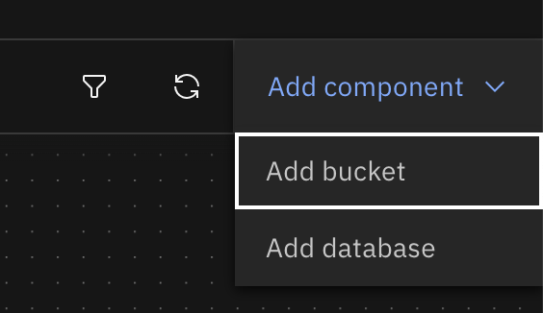

Step 11:

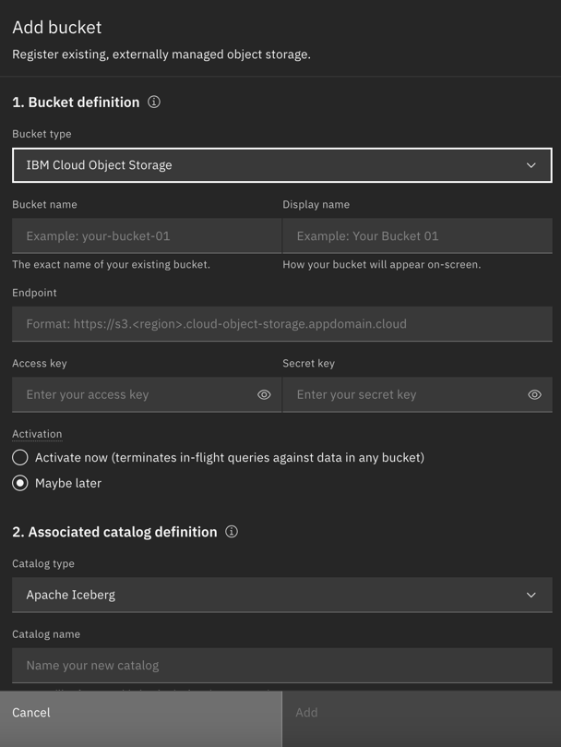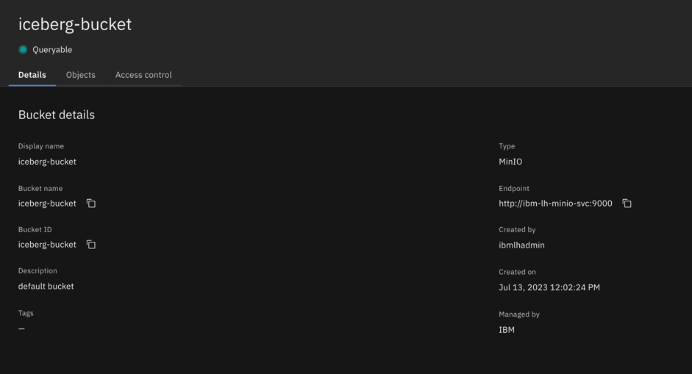Details related to buckets

In our case the iceberg details are shown in the right side window.

Step 12:

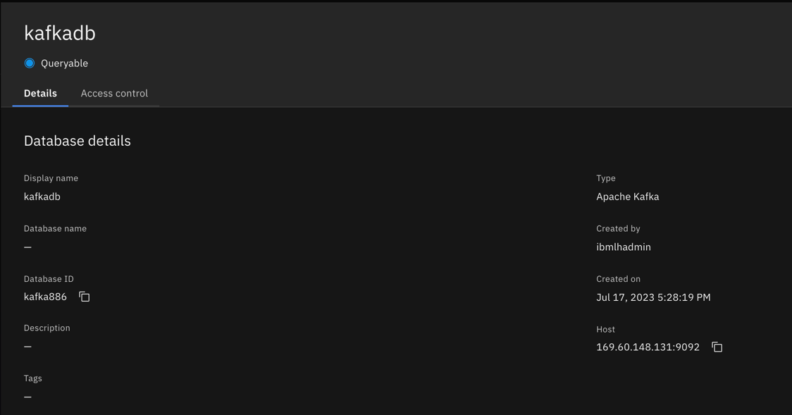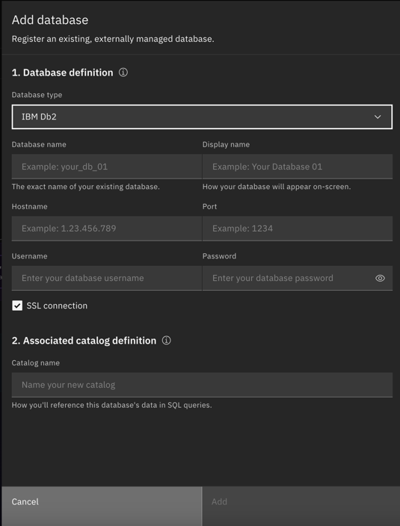Details related to Database:

In our case the database details are available in right side window.

Load data in kafka topic:

Execute script to load the data in tpch.orders

./gen_data orders.tpl tpch.orders



Step 13:

Start Jupyter notebook

**jupyter** notebook --ip=169.60.148.131 --port=8888 --allow-root --notebook-dir=/root/ &

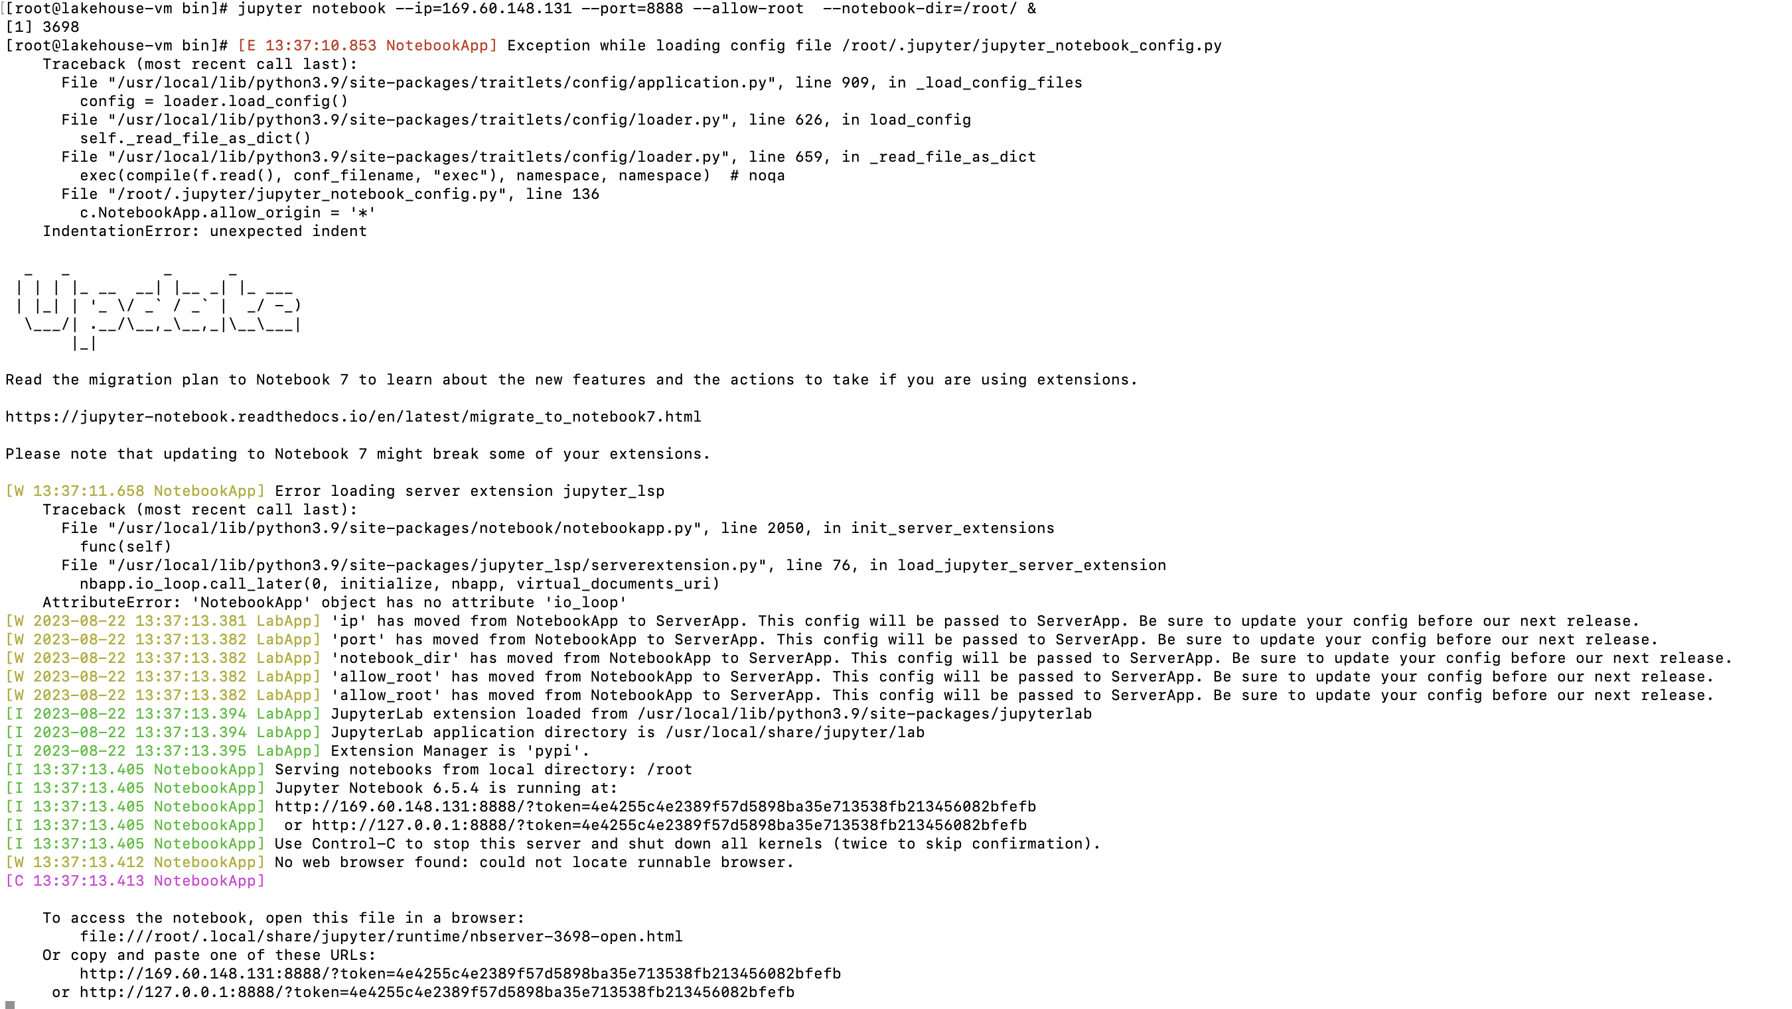

Use the URL generated by jupyter notebook server to interact with watsonx.data

<http://169.60.148.131:8888/?token=4e4255c4e2389f57d5898ba35e713538fb213456082bfefb>

Step 14:

Open the python notebook file to execute on the watsonx.data box

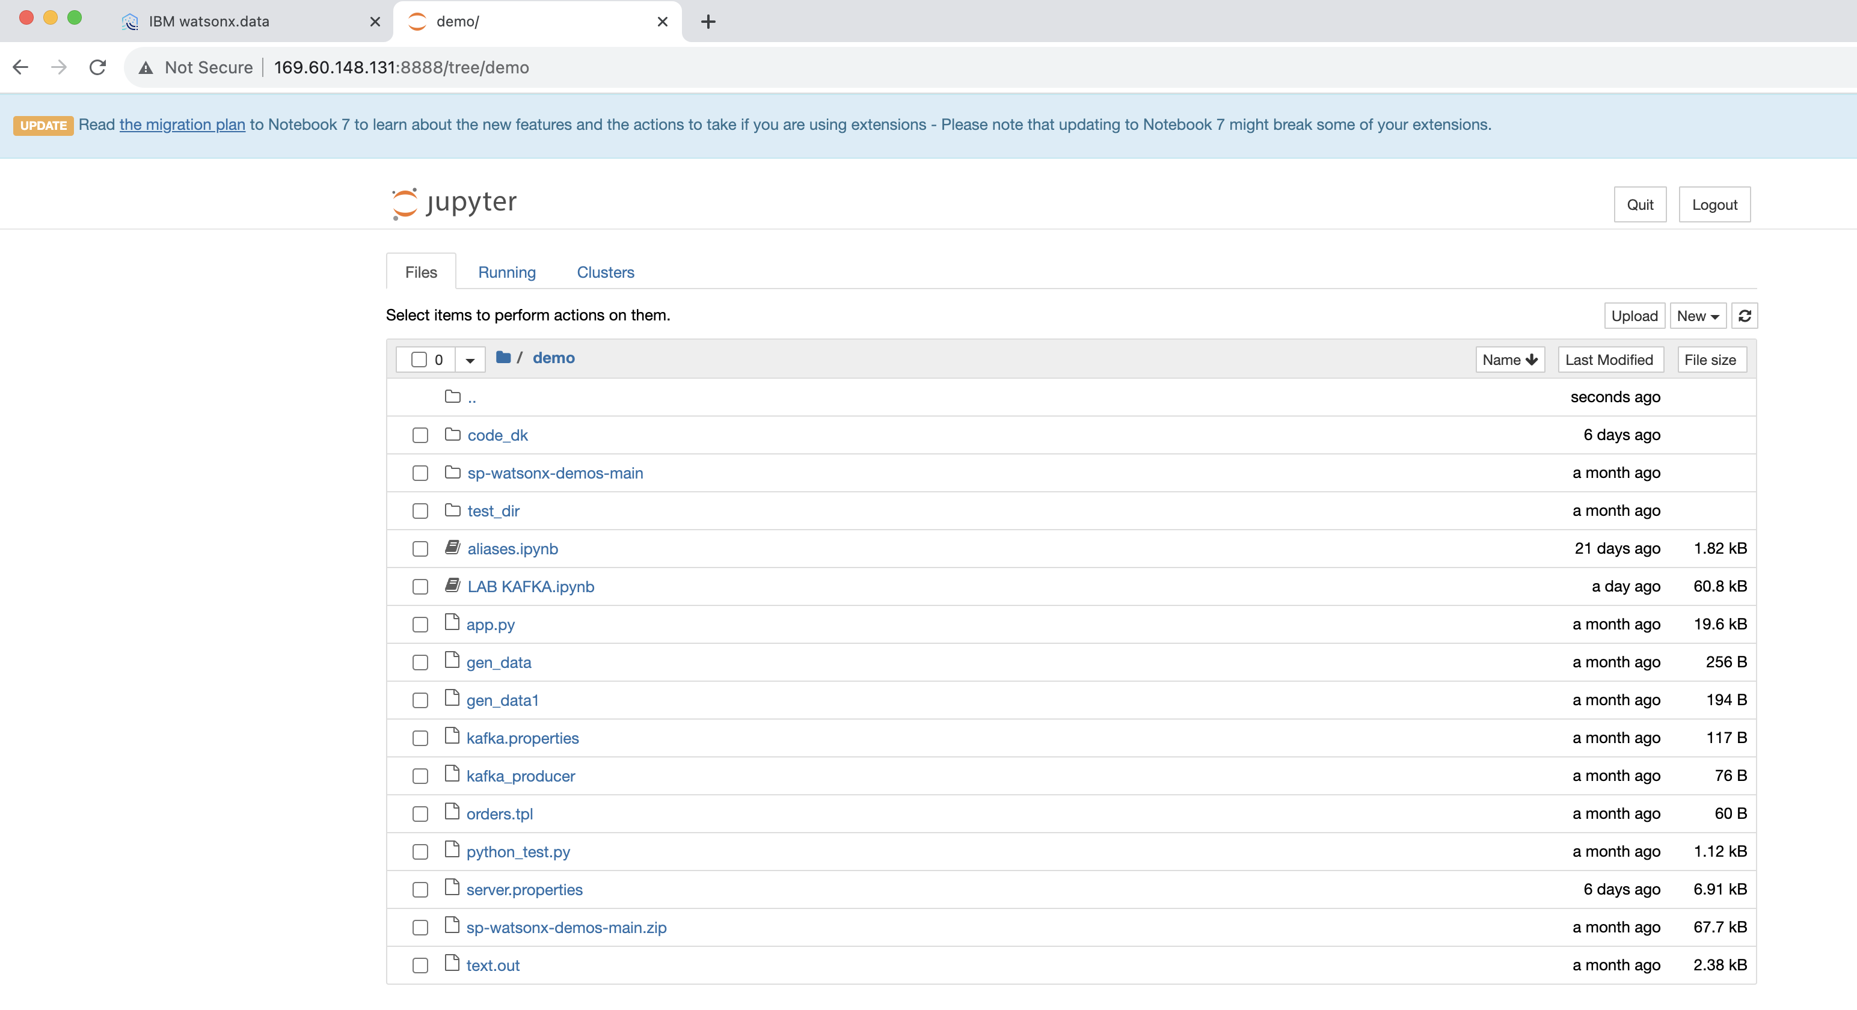

Step 15:

Now we are ready with the environment and ready to query the watsonx.data using Query workspace available on watsonx.data as well as using python notebook

1. Here we would like to read the messages loaded in kafka topics by using gen_data script

SQL Query:

SELECT _message FROM "kafkadb"."tpch"."orders" LIMIT 10;

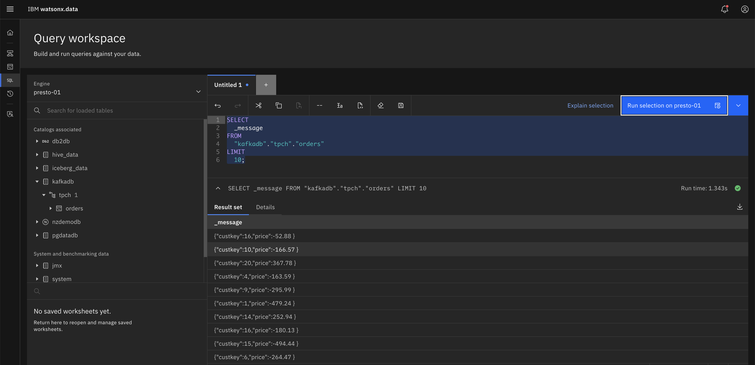

1. Here we would like to query the table customer from workshop schema and iceberg data datasets

SQL Query:

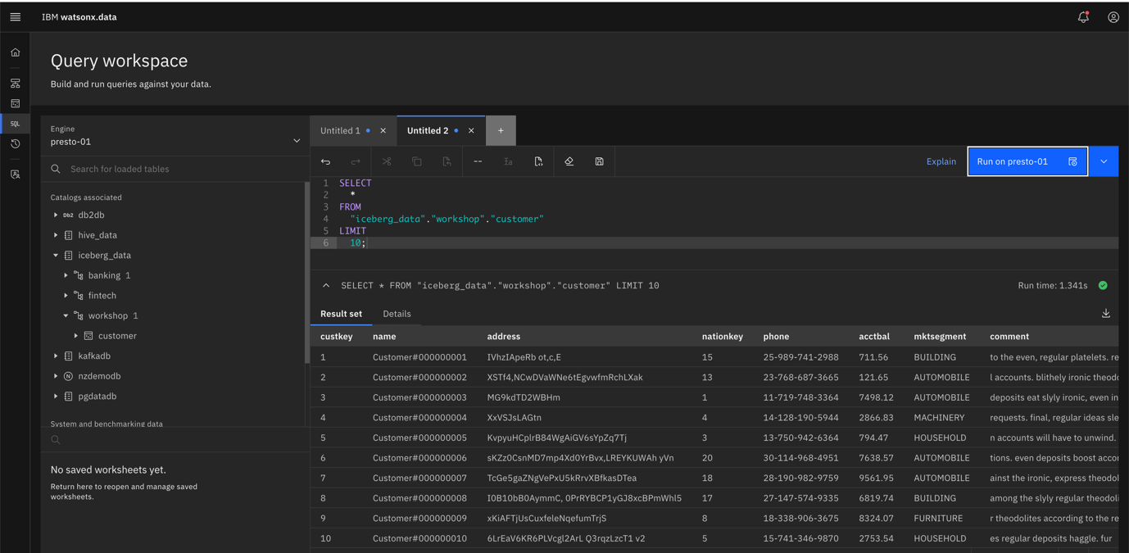SELECT * FROM "iceberg_data"."workshop"."customer" LIMIT 10;

1. Now we would like to federate the records by using these two heterogeneous source systems one is streaming engine kafka and other is iceberg datasets

SQL Query:

with

t1 as (

SELECT cast(json_extract(_message,'$.custkey') as int) custkey,

cast(json_extract(_message,'$.price') as real) price

FROM kafkadb.tpch.orders),

t2 as (

SELECT * FROM iceberg_data.workshop.customer

)

SELECT t2.mktsegment,avg(t1.price) as avg_price

FROM t1 JOIN t2

ON t1.custkey=t2.custkey

GROUP BY 1 ORDER BY 1

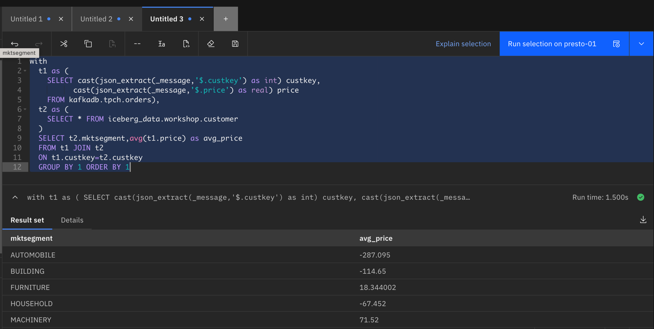

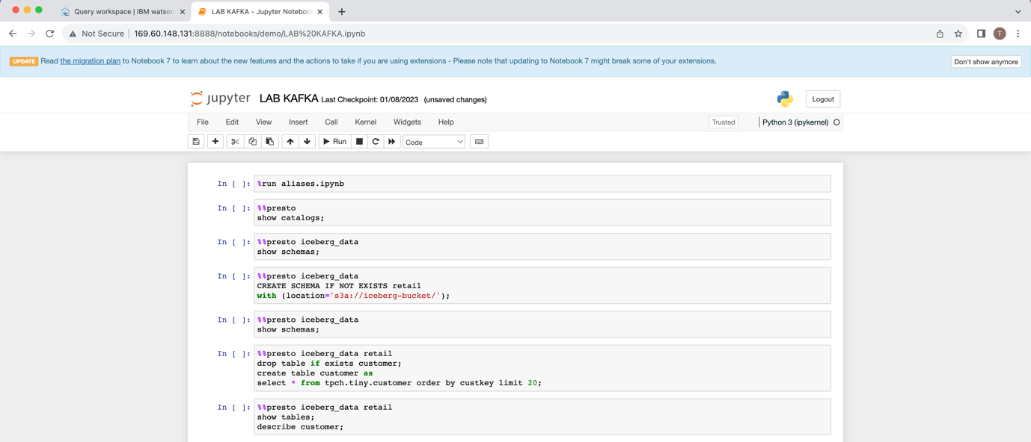Now we are good with the SQL Query execution on watsonx.data platform using presto engine on heterogeneous sources.

Another Approach we can see by using Python notebook.

Step 16:

Open the URL of python notebook

<http://169.60.148.131:8888/notebooks/demo/LAB%20KAFKA.ipynb>

Run commands one by one and get the output on the same screen

Step 17:

In image you can see the python code to plot graph for the sales aggregation based on market segment.

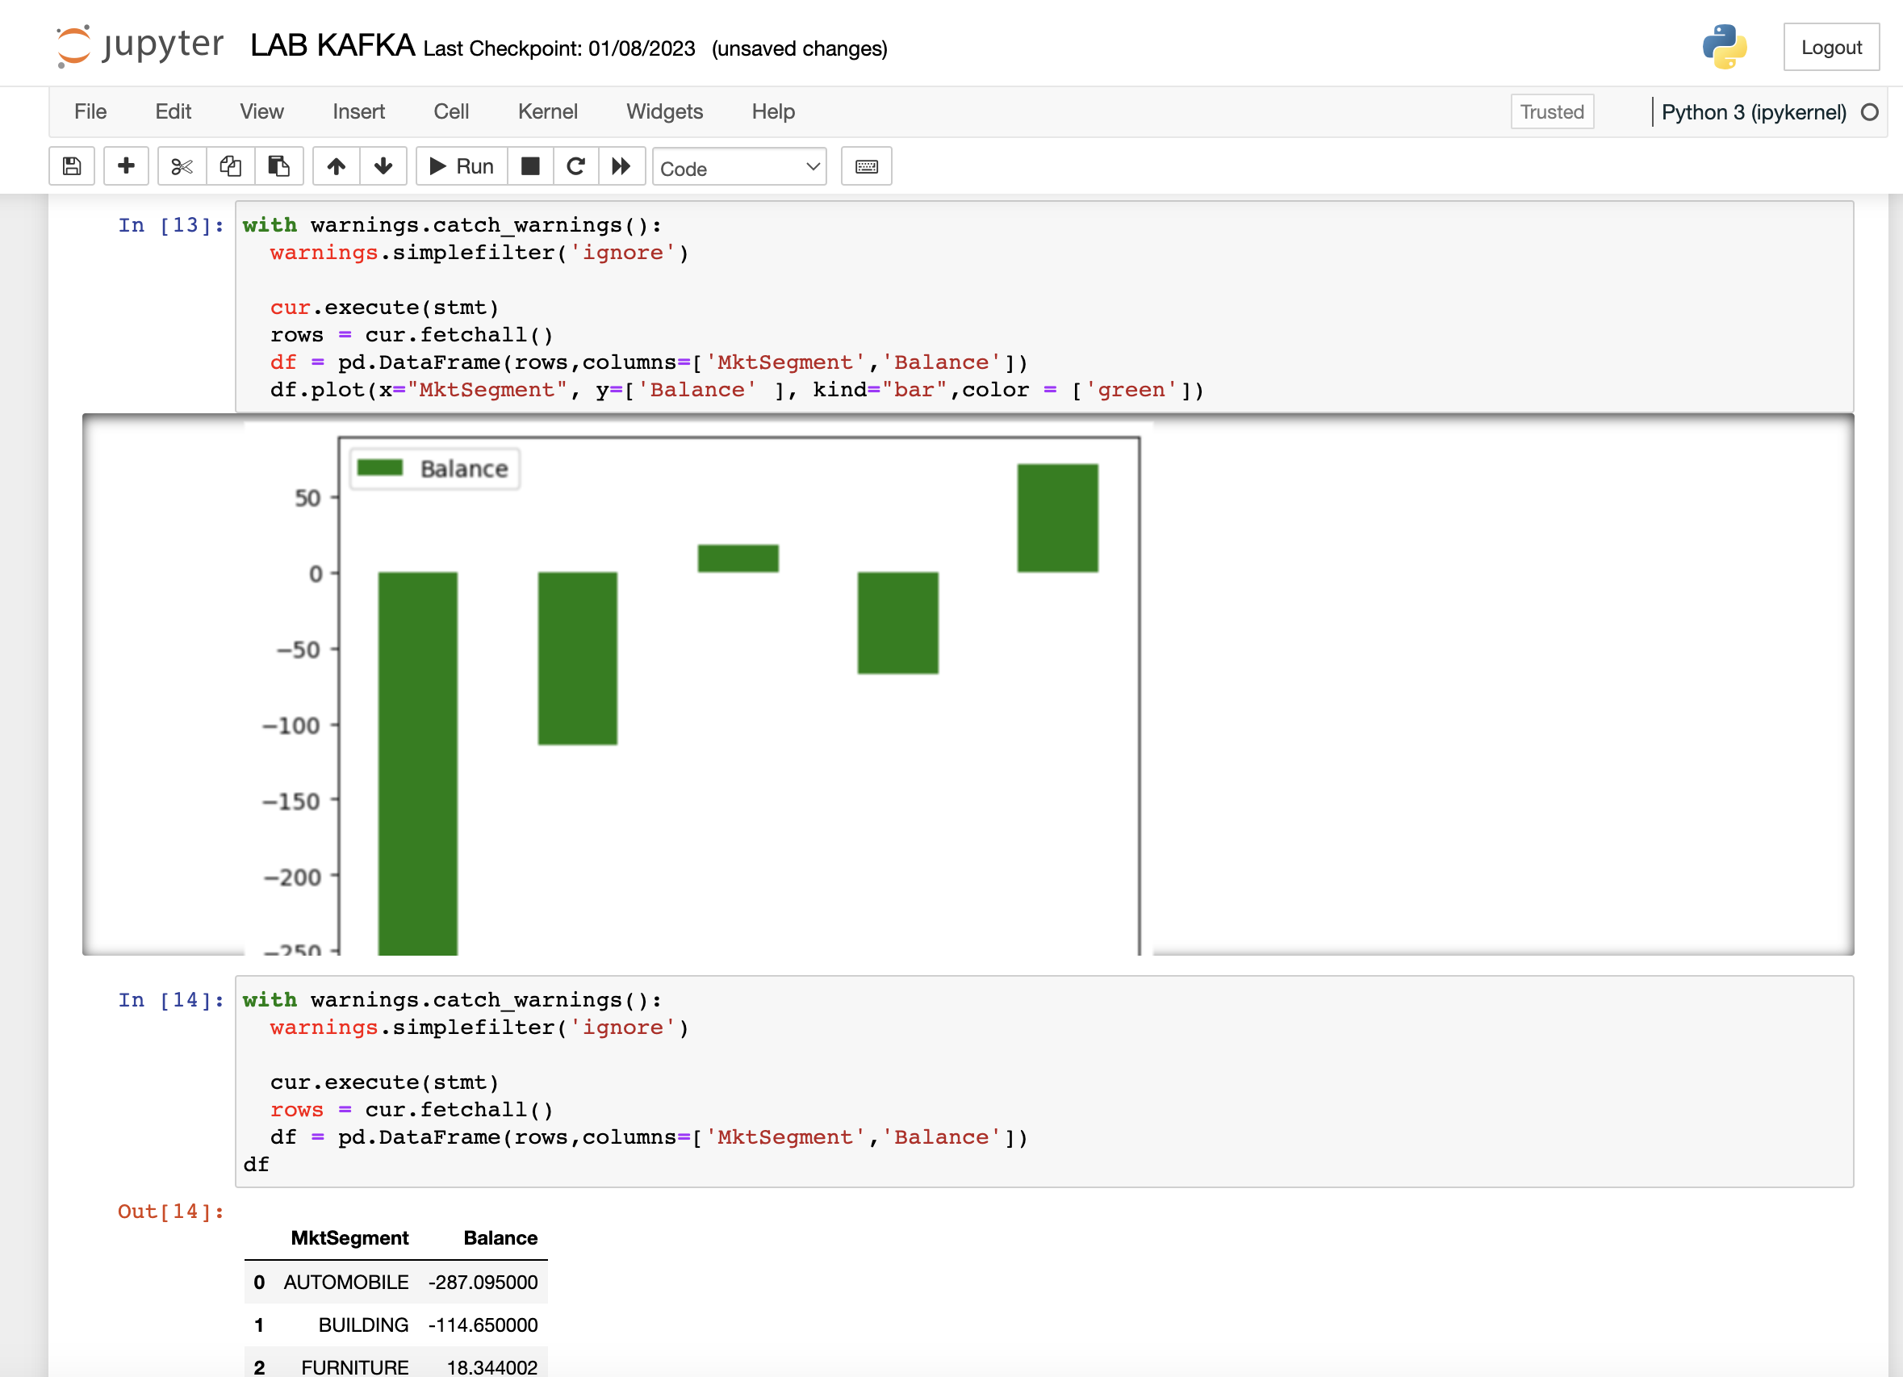

**Conclusion**

In this lab, you've learned how to connect to Watsonx.data using the Presto CLI and executed queries to explore available catalogs, schemas, tables, functions, and gather statistics. This knowledge will help you navigate and utilize Watsonx.data effectively for your data exploration needs.